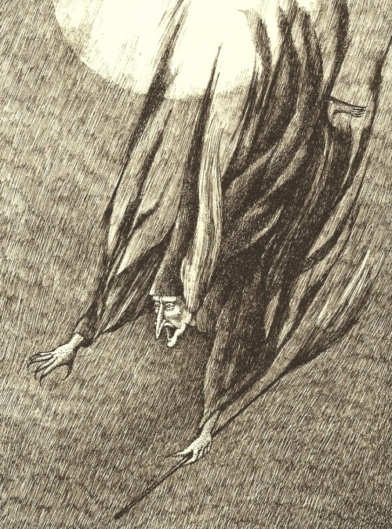
THE WITCH
She comes by night, in fearsome flight, Paraphrase on back:
in garments black as pitch, Rhyme Scheme:
the queen of doom upon her broom, Sound devices:
the wild and wicked witch,
a cackling crone with brittle bones Figurative Language:
and desiccated limbs,
two evil eyes with warts and sties
and bags about the rims,
a dangling nose, ten twisted toes Diction:
and folds of shriveled skin,
cracked and chipped and crackled lips
that frame a toothless grin.
She hurtles by, she sweeps the sky Imagery:
and hurls a piercing screech.
As she swoops past, a spell is cast
on all her curses reach.
Take care to hide when the wild witch rides Syntax:
to shriek her evil spell.
what she may do with a word or two
is much too grim to tell. Tone:
—Nightmares: Poems to Trouble Your Sleep by Jack Prelutsky, illustrated by Arnold Lobel

