Sentence Patterns
While it is important to consider the length of a sentence based on the number of clauses, i.e., simple, compound, complex or compound complex, it is also worth noting that there are some patterns that sentences can follow. The position of the main idea in the sentence is what determines the pattern.

The Loose Sentence
The loose sentence is one in which the main ideas occurs in the first part of the sentence. Most sentences follow this pattern as a rule.
1 Their baggage followed a few days later.
Example: Most planes float for a few minutes; this was illustrated when a US Airways plane landed safely on the Hudson River after both its engines were disabled by birds being sucked into the turbines.
Flying is statistically still the safest way to travel, despite the accidents which are often reported by the media.

The Periodic Sentence
Sometimes it can be effective to save the main idea of a sentence until the end of the sentence. Like exclamatory sentences, it is best to use this pattern sparingly or else you risk sounding like a very dull university professor.
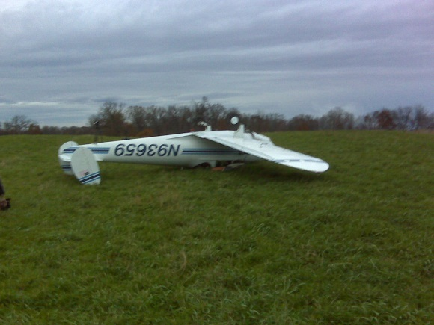
Example: When a US Airways plane safely landed on the Hudson River after both of its engines were disabled by bird strikes, the general public was vividly acquainted with a startling fact: most planes will stay afloat for a few minutes, long enough for passengers to evacuate safely.
Despite the gruesome accidents that often gain lurid media attention, it is indisputable that flying remains the safest way to travel.
2 Still the safest way to fly

The Balanced Sentence
A balanced sentence contains two main ideas. The ideas are presented as co-equal; the best format for a balanced sentence is typically a compound sentence or a compound-complex sentence.
Example: Statistically speaking, plane travel is still the safest way to travel; even in a water landing, planes will stay afloat for several minutes.
People who survive emergency situations are those who stay calm; likewise, those who pay attention to emergency instructions also fare well.

The Parallel Sentence
This pattern is a bit trickier. It is often used as a rhetorical device to lend balance, grace, rhythm, and, most importantly, clarity to a sentence. Essentially, it involves the intentional repetition of key grammatical elements (such as verbs or phrases). Several parts of a sentence or several sentences are expressed similarly to show that the ideas in the parts or sentences are equal in importance.
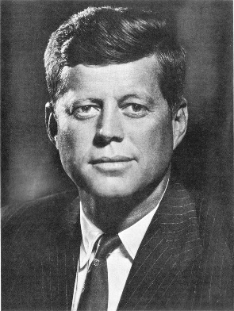
Example: Quickly and happily he walked around the corner to buy the book. (Repetition of adverbs)
He liked to eat watermelon and to avoid grapefruit. (Repetition of verbs and their direct objects)
Ask not what your country can do for you; ask what you can do for your country. (John F. Kennedy’s famous quotation)

More information on sentence types and grammar in general can be found at the University of Ottawa’s writing site.
http://www.writingcentre.uottawa.ca/hypergrammar/grammar.html

Exercise A: Highlight the main idea(s) of each sentence in yellow. Then, identify whether the following patterns are loose, periodic, balanced or parallel sentences.
- The bird went higher in the air and circled again, his wings motionless.
- The clouds over the land now rose like mountains and the coast was only a long green line with the gray blue hills behind it.
- He had no mysticism about turtles although he had gone turtle boats for many years.
- Eat them, fish. Eat them. Please eat them.
- Then the weight increased and he gave more line.
- When the sun had risen further, the old man realized that the fish was not tiring.
- The old man could see that he was very tired.
- He knew he would need his hands before this was over and he did not like to be cut before it start.
- But I must have confidence and I must be worthy of the great DiMaggio who does all tings perfectly even with the pain of the bone spur in his heel.
- But his left hand had always been a traitor and would not do what he called on it to do and he did not trust it.
Part B: Highlight the main idea(s) of each sentence in yellow. Then, identify whether the following patterns are loose, periodic, balanced or parallel sentences. Then identify whether they are simple, compound, complex or compound-complex sentences.
1. The dolphin looks green of course because he is really golden.

2. Just before dark, as they passed a great island of Sargasso weed that heaved and swung in the light sea as though the ocean were making love with something under a yellow blanket, his small line was taken by a dolphin.

3. The setting of the sun is a difficult time for all fish.

4. My hand is only cut a little and the cramp is gone from the other.

5. Now I must think about the drag.

6. If you do not sleep, you might become unclear in the head.
Section C: Based on what you have observed, what is the general relationship between sentence types (simple, compound, complex, compound-complex) and sentence pattern?

Section D: In your assigned chapter, find two examples of each sentence pattern. Also identify the sentence type.

